**Creating a Ticket for Establishing a VPN Connection**

**Approval Table:**

Document creator: Gabriel Linski, first issued Feb 13th 2024

Phone XXX-XXXX Ex XXX

Email: [G_Linski@hotmail.com](mailto:G_Linski@hotmail.com)

Document Reviewers:

Navjot Kaur reviewed Feb 2nd 2021.

Billy Fakename reviewed April 15th 2023.

**People**

IT Help Desk: Janice Smith

System Admin: Mark Pullman

**RACI Chart**

|  |  |  |  |  |  |
| --- | --- | --- | --- | --- | --- |
|  | IT Support Desk  *Jill Stein* | Tech Storeroom Manager | IT Support | IT Supervisor | IT Senior Manger |
| Ticket Creation | R |  | IC | I | I |
| Company Issued Device | AI | R | I | I | I |
| VPN Credentials | AI | I | RI | C | I |
| Connection Establishment |  |  | R | AC |  |
| Connection Testing |  |  | R | AC |  |

R = Responsible, A = Accountable, C = Consulted, I =Informed

**Scope**

After completion the issued employee will be able to access the company’s, TechSolutions, virtual private network (VPN) from your issued device(s). The issued employee will be required to connect to this VPN when working remotely to ensure their data and the clients data are protected. Connection to the VPN will be required access of the company’s internal systems, whether uploading or downloading confidential data. This process will require the user to be issued a company computer and user credentials beforehand.

**Purpose**

Creating a VPN connection for remote workers is to ensure data privacy. On this VPN traffic will be encrypted, preventing intrusions and leaks of confidential data.

**Steps for Establishing a VPN Connection**

1) From your company issued device, 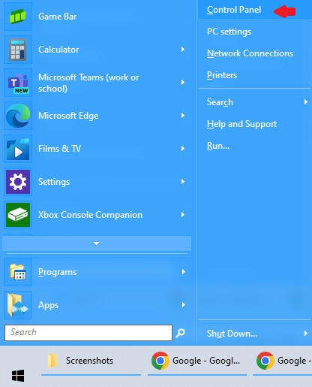click the Windows star menu in the lower left and select control panel:

2) In the control panel settings select Network & Internet:



3) On the lefthand side click VPN.

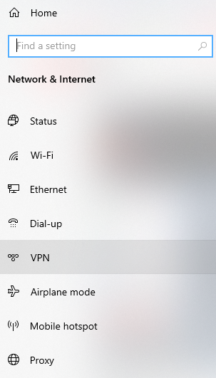

4) Click Add a VPN connection.

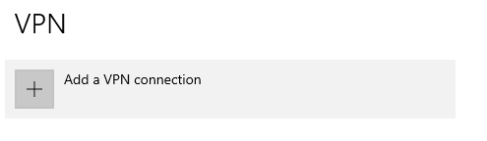

5) In the Add a VPN connection screen, you will be required to fill out the form according to company's VPN configuration standards. User name and a temporary password will be provided. The user will need to change password after initial connection login.

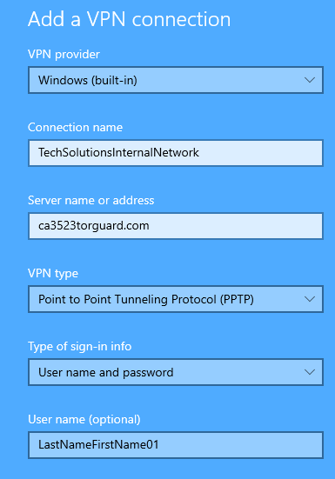

6) Connect to the VPN using the preceding credentials.

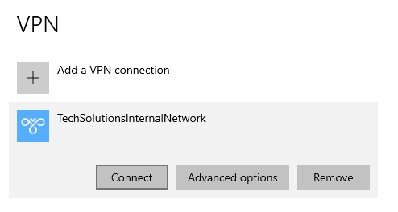

**Revision History**